3.2.2 Use Case Descriptions
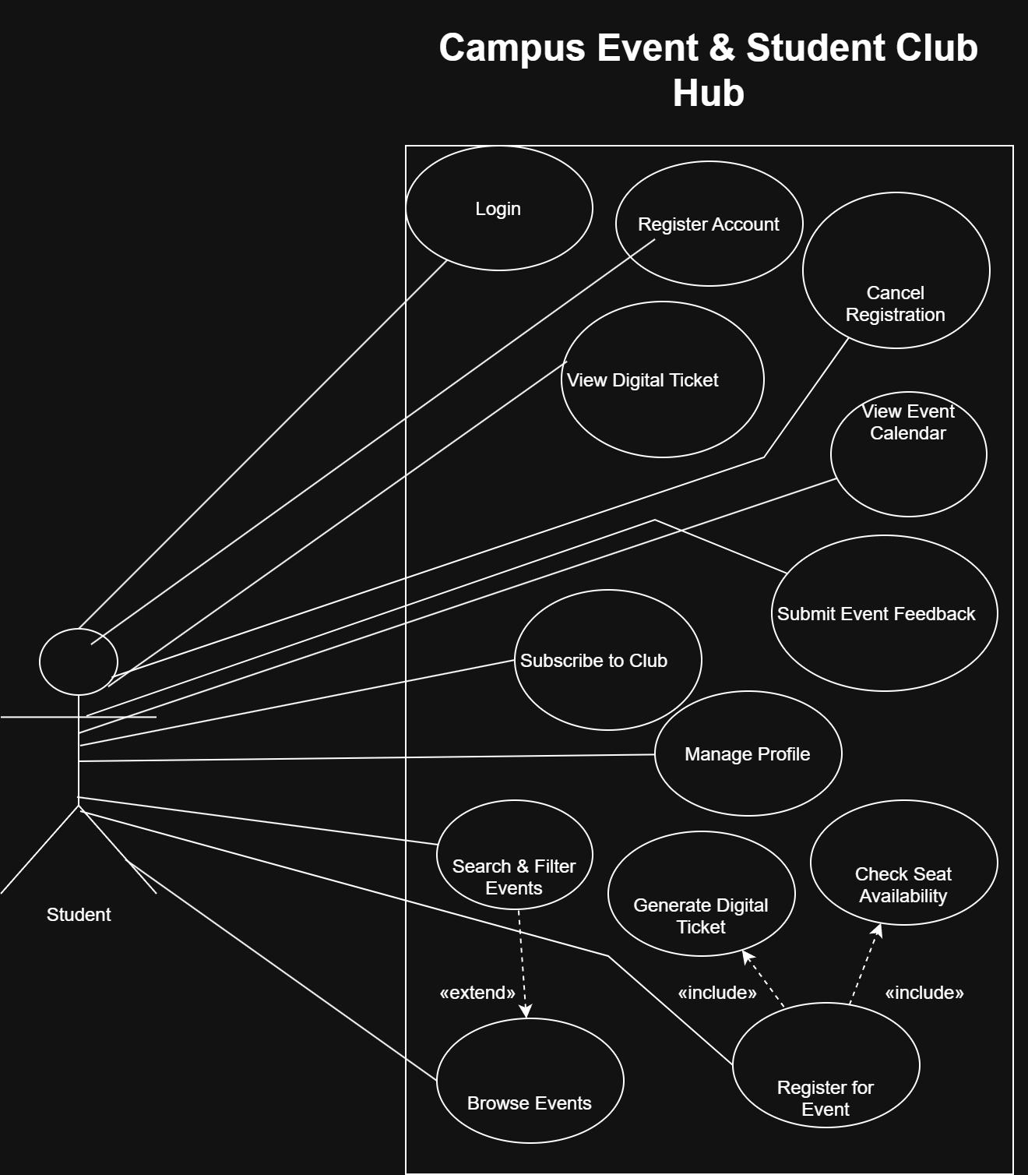

Student Use Cases
1. Register Account
Use Case ID: UC-ST-01
Primary Actor: Student
Related Requirement: FR-1
Preconditions:
- The student has a valid Zewail City university email.
- The student does not have an existing account.
Main Flow:
- The student opens the registration page.
- The system displays the registration form.
- The student enters their full name, university email, and password.
- The system validates the entered information and verifies the university email domain.
- The system creates the student account.
Alternative Flows:
- If the email does not belong to the university domain, the system rejects registration.
- If the email is already registered, the system displays an error message.
Postconditions:
- A new student account is successfully created.

2. Login
Use Case ID: UC-ST-02
Primary Actor: Student
Related Requirement: FR-2
Preconditions:
- The student has an existing account.
Main Flow:
- The student opens the login page.
- The system displays the login form.
- The student enters their university email and password.
- The system verifies the credentials.
- The system redirects the student to the dashboard.
Alternative Flows:
- If the credentials are incorrect, the system displays an error message.
- If the student forgets their password, the system provides a password recovery option via email.
Postconditions:
- The student is successfully authenticated.

3. Manage Profile
Use Case ID: UC-ST-03
Primary Actor: Student
Related Requirement: FR-3
Preconditions:
- The student is logged into the system.
Main Flow:
- The student opens the profile settings.
- The system displays the student's current personal information.
- The student updates their profile details, such as their major or profile picture.
- The student clicks Save.
- The system validates and saves the updated information.
Alternative Flows:
- If invalid information is entered, the system displays an error message.
- If the student cancels the operation, the existing information remains unchanged.
Postconditions:
- The student's personal profile is successfully updated.

4. Browse Events
Use Case ID: UC-ST-04
Primary Actor: Student
Related Requirement: FR-7
Preconditions:
- The student can access the event dashboard.
Main Flow:
- The student opens the event dashboard.
- The system retrieves all approved upcoming events.
- The system displays the events in chronological order.
- The student browses the available events.
- The student selects an event to view its details.
Alternative Flows:
- If no approved upcoming events are available, the system displays an appropriate message.
Postconditions:
- The student can view the available campus events.

5. Search & Filter Events
Use Case ID: UC-ST-05
Primary Actor: Student
Related Requirement: FR-8
Preconditions:
- The student has access to the event dashboard.
Main Flow:
- The student opens the event dashboard.
- The student enters a search keyword or selects filtering options.
- The student chooses a date range or club category.
- The system processes the selected search criteria.
- The system displays matching approved events.
Alternative Flows:
- If no events match the search criteria, the system displays a No Results message.
- If the student clears the filters, the system displays all approved upcoming events.
Postconditions:
- The student can view events matching the selected criteria.

6. Register for Event
Use Case ID: UC-ST-06
Primary Actor: Student
Related Requirement: FR-9
Preconditions:
- The student is logged into the system.
- The event has been approved by the Admin.
- The event is open for registration.
Main Flow:
- The student opens the event details page.
- The student selects Register for Event.
- The system checks seat availability.
- The system confirms that seats are available.
- The system records the student's registration.
- The system generates a digital ticket containing a unique QR code.
- The system displays a successful registration confirmation.
Alternative Flows:
- If no seats are available, the system disables registration and displays Sold Out.
- If the registration cannot be completed, the system displays an error message.
Postconditions:
- The student is registered for the event.
- A digital ticket is generated.

7. Check Seat Availability
Use Case ID: UC-ST-07
Primary Actor: Student (through Register for Event)
Related Requirement: FR-9
Preconditions:
- The student has selected an event for registration.
Main Flow:
- The system retrieves the event's maximum capacity.
- The system checks the number of confirmed registrations.
- The system calculates the number of available seats.
- The system determines whether registration is possible.
- The system returns the availability result.
Alternative Flows:
- If no seats remain, the system prevents registration and displays Sold Out.
Postconditions:
- Seat availability is verified before registration confirmation.

8. Generate Digital Ticket
Use Case ID: UC-ST-08
Primary Actor: Student (initiates event registration)
Related Requirement: FR-11
Preconditions:
- The student's event registration has been successfully confirmed.
Main Flow:
- The system receives confirmation of successful registration.
- The system generates a unique digital ticket.
- The system creates a QR code associated with the registration.
- The system saves the digital ticket.
- The system makes the ticket available on the student's dashboard.
Alternative Flows:
- If ticket generation fails, the system displays an error message and does not report ticket issuance as successful.
Postconditions:
- A digital ticket containing a QR code is available to the registered student.

9. View Digital Ticket
Use Case ID: UC-ST-09
Primary Actor: Student
Related Requirement: FR-11
Preconditions:
- The student is logged into the system.
- The student has a successfully generated digital ticket.
Main Flow:
- The student opens their dashboard.
- The student selects the registered event.
- The student selects View Digital Ticket.
- The system retrieves the corresponding ticket.
- The system displays the QR code and ticket information.
Alternative Flows:
- If no ticket exists for the selected registration, the system displays an appropriate message.
Postconditions:
- The student can view the digital ticket for event entry.

10. Cancel Registration
Use Case ID: UC-ST-10
Primary Actor: Student
Related Requirement: FR-10
Preconditions:
- The student is logged into the system.
- The student has an existing event registration.
- The event has not started.
Main Flow:
- The student opens their registered events.
- The student selects the registration to cancel.
- The student clicks Cancel Registration.
- The system requests confirmation.
- The student confirms the cancellation.
- The system removes the student's registration from the attendee list.
- The system releases the reserved seat.
Alternative Flows:
- If the student cancels the confirmation, the registration remains unchanged.
- If the event has already started, the system prevents cancellation.
Postconditions:
- The student's registration is canceled.
- The available seat count increases by one.

11. Subscribe to Club
Use Case ID: UC-ST-11
Primary Actor: Student
Related Requirement: FR-16
Preconditions:
- The student is logged into the system.
- The selected club exists.
Main Flow:
- The student opens the club's profile.
- The student selects Subscribe to Club.
- The system records the subscription.
- The system adds the student to the club's follower list.
- The system confirms the subscription.
Alternative Flows:
- If the student is already subscribed, the system displays the current subscription status.
Postconditions:
- The student is subscribed to the selected club and can receive relevant club notifications.

12. Submit Event Feedback
Use Case ID: UC-ST-12
Primary Actor: Student
Related Requirement: FR-18
Preconditions:
- The student is logged into the system.
- The event has ended.
- The student attended the event.
Main Flow:
- The student opens a previously attended event.
- The student selects Submit Event Feedback.
- The system displays the feedback form.
- The student enters a rating and a short written review.
- The student submits the feedback.
- The system validates and saves the feedback.
Alternative Flows:
- If the event has not ended, the system prevents feedback submission.
- If the rating is invalid or required information is missing, the system requests corrections.
Postconditions:
- The student's feedback is saved and associated with the event.

13. View Event Calendar
Use Case ID: UC-ST-13
Primary Actor: Student
Related Requirement: FR-19
Preconditions:
- The student can access the platform's event calendar.
Main Flow:
- The student opens the Event Calendar page.
- The system retrieves approved campus events.
- The system displays events in a monthly calendar view.
- The student navigates between months.
- The student selects an event to view its details.
Alternative Flows:
- If no approved events are scheduled for the selected month, the system displays an empty calendar.
Postconditions:
- The student can view approved campus events in calendar format.

